1. b) Consider the following.Find the values of the resulting matrix , when the following elementary row operation are applied in the given order.

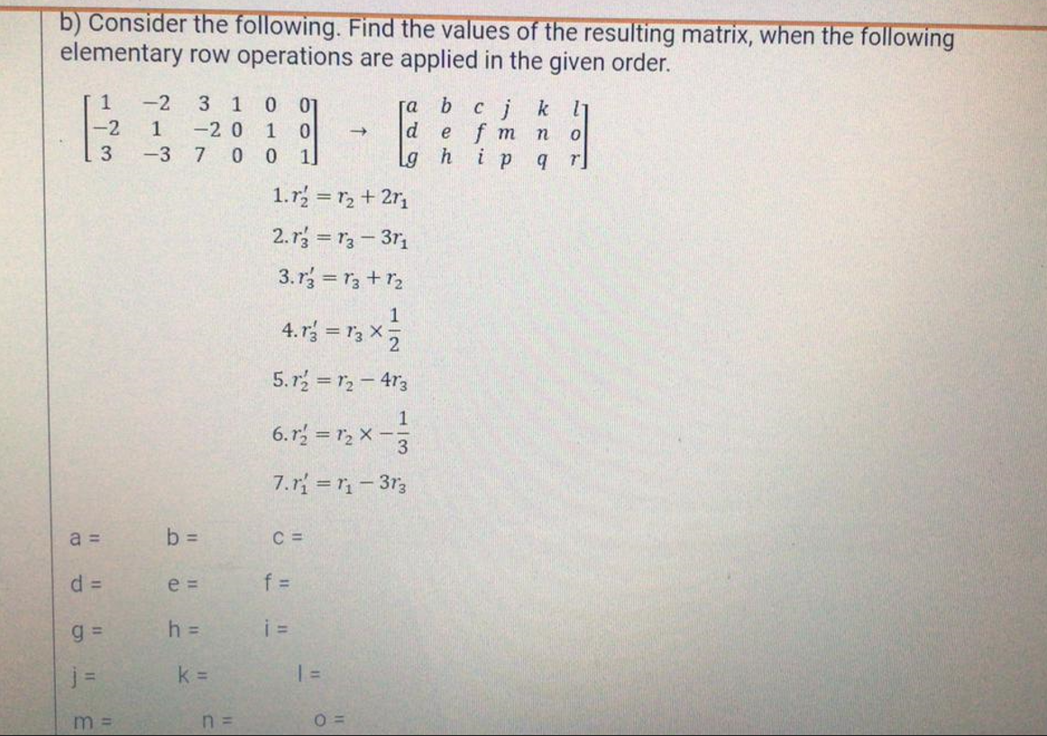

1. 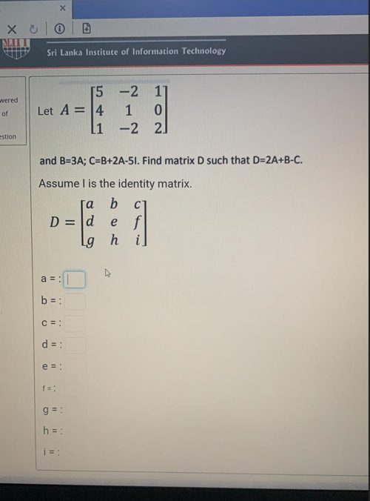Let A=[ ] and B=3A; C=B+2A-5I.Find matrix D such that D= 2A+B-C

5 -2 1

4 1 0

1 -2 2

1. Let A=[ ] and B=3A; C=B+2A-5I.Find matrix D such that D= 2A+B-C

5 -5 4

0 3 2

1 0 7

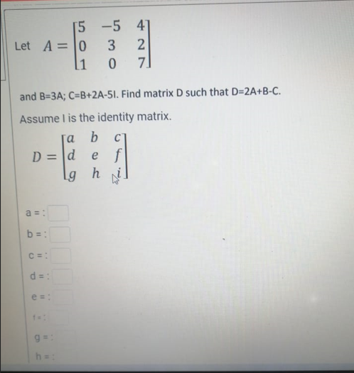

1. Let A=[ ]Find B = A2- 3A +2I
2. 2

3 0

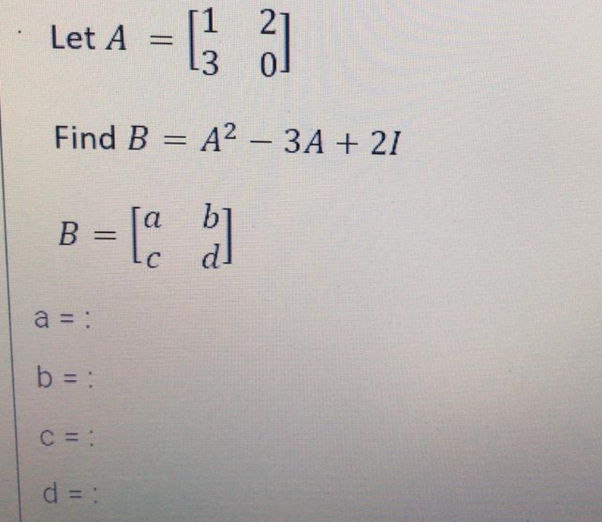

1. 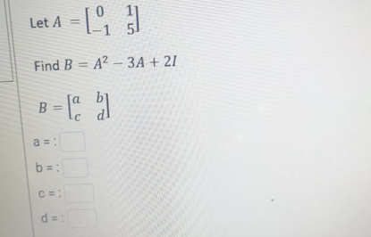Let A=[ ]Find B = A2- 3A +2I

0 1

-1 5

1. 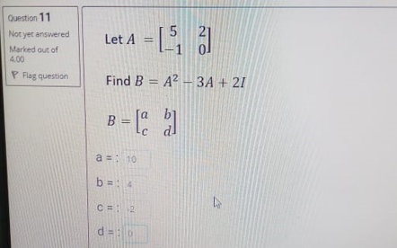Let A=[ ]Find B = A2- 3A +2I
2. 2

-1 0

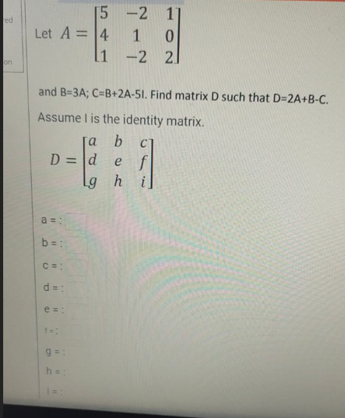

1. Sum of the two digits of a two- digit number is 15. When the sum of two and twice the ten digit is divided by 2 gives the unit digit. Write down 2 equations to find the unit digit (Y) and tens digit (X)

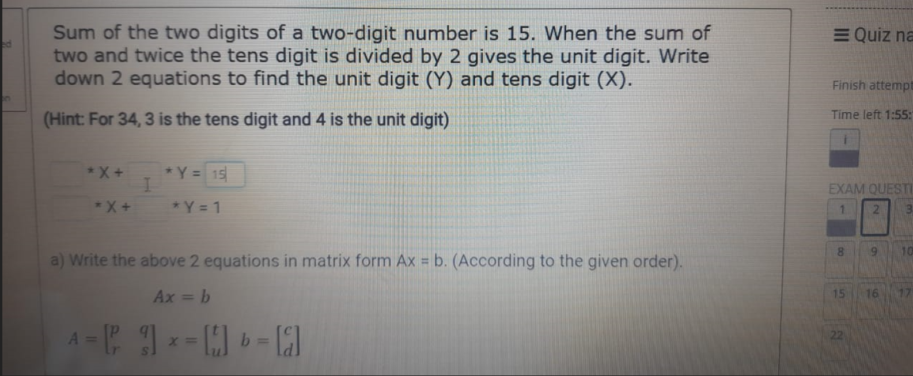

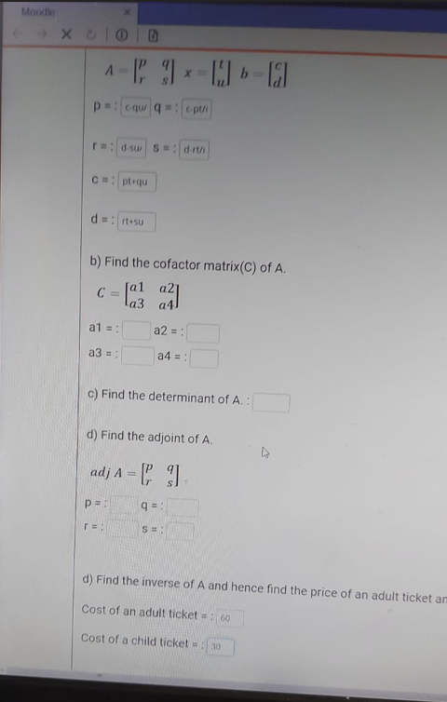 A=[ ] x=[ ] b=[ ]

p q

r s



t

u

c

d

1. If |A|=43 then find the cofactor matrix of A.

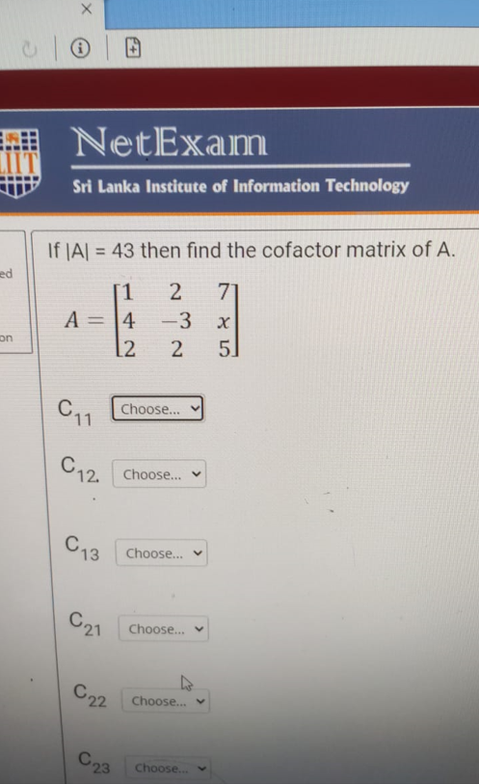

1. If |A|=128 then find the cofactor matrix of A.

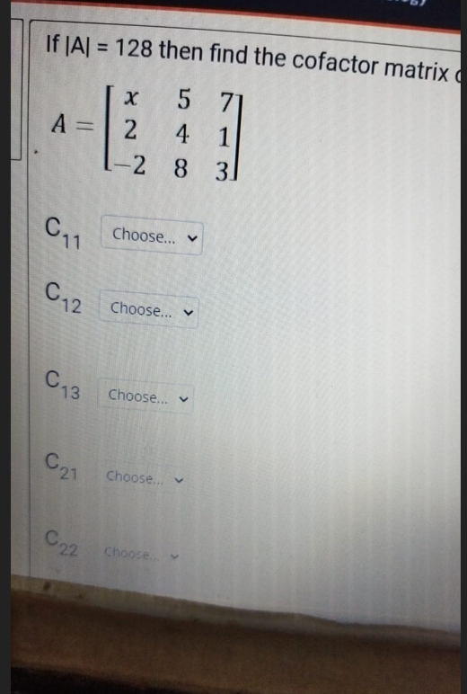

1. 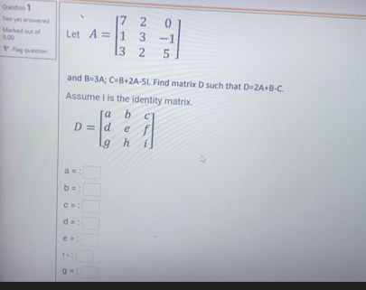Let A=[ ]Find B = 3A; C=B+2A-5I.Find matrix D such that D=2A+B-C.
2. 2 0

1 3 -1

3 2 5

1. b)Find the determinant of A. :

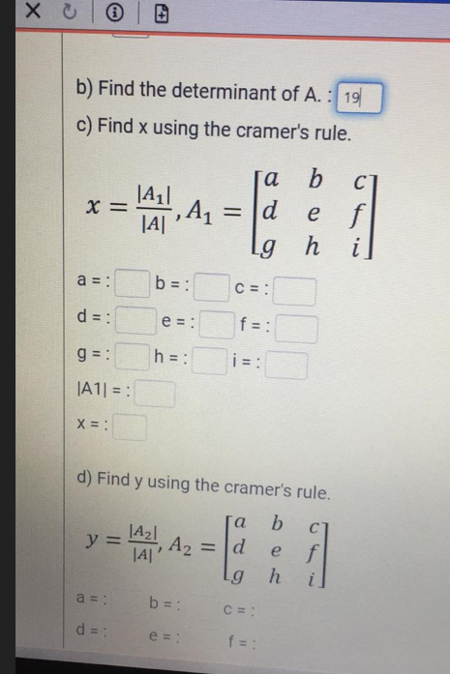c)Find x using the cramer’s rule.

1. Consider the following linear system of equations.

2x+y-3z=1

3y-2z=-1

3x+y-z=8

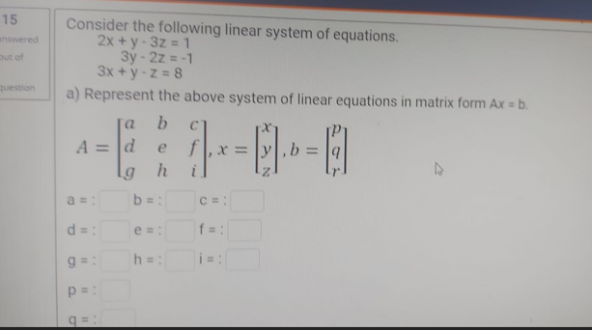

1. Consider the following linear system of equations.

X+2y-2z=2

2x+y-z=-2

3x+2y-z=-1

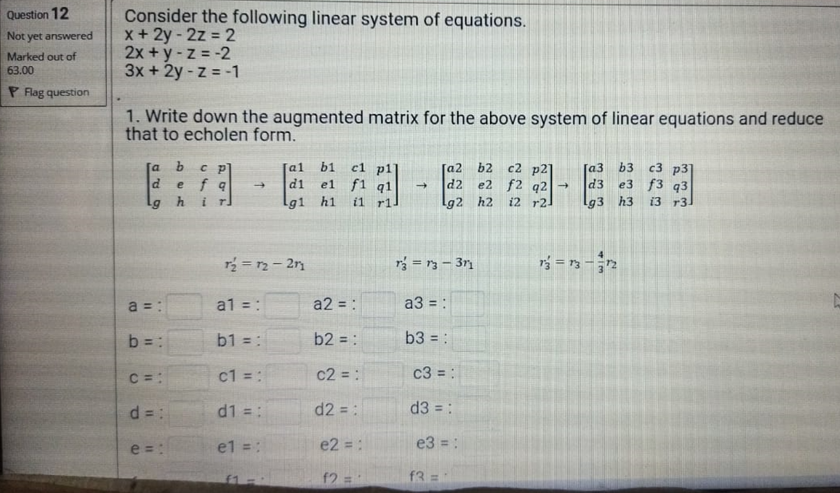

1. Consider the following linear system of equations.

X+2y-z=-1

3y+z=2

2x+y-z=0

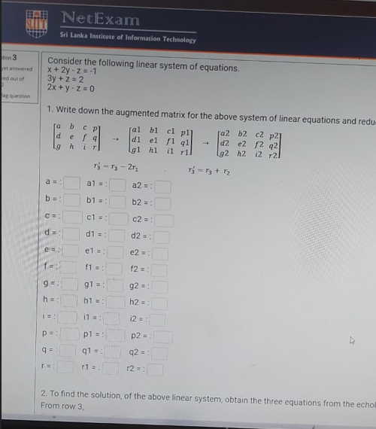

1. Consider the following linear system of equations.

x-2y+3z=-2

-2x +y-2z=2

3x-3y+7z=-2

